Position and Velocity Vs. Time Graphs

Sketch position vs. time and velocity vs. time graphs for the following scenarios. If specific distances, velocities, and times are given, label them on your graphs. For simplicity’s sake, assume all movement is in a straight line.

1) Your mother walks five meters to the kitchen at a velocity of 2 m/s, pauses by the refrigerator for three seconds, then walks back with a plate full of potato salad at a velocity of 1 m/s.

2) A car is driving down the road at 55 mph, and after getting a flat tire moves at 35 mph.

3) A bullet is fired from a gun and travels 1000 meters in one second before hitting a solid target.

4) A circus elephant picks up a clown (who is not moving) and throws him across the ring at high speed.

5) At track practice, the coach makes the team members run back and forth between two lines three times.

6) When you hit a golf ball, it travels through the air at 25 m/s, then decelerates once it hits the ground 100 meters away until it comes to a stop 110 meters away.
Position and Velocity Vs. Time Graphs

Sketch position vs. time and velocity vs. time graphs for the following scenarios. If specific distances, velocities, and times are given, label them on your graphs. For simplicity’s sake, assume all movement is in a straight line.

1) Your mother walks five meters to the kitchen at a velocity of 2 m/s, pauses by the refrigerator for three seconds, then walks back with a plate full of potato salad at a velocity of 1 m/s.
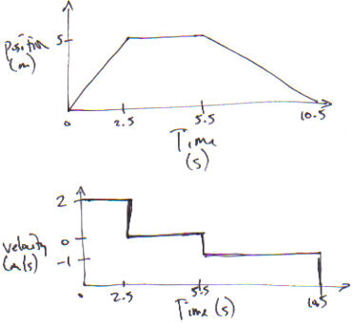

2) A car is driving down the road at 55 mph, and after getting a flat tire moves at 35 mph.
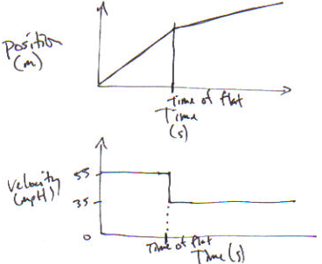

3) A bullet is fired from a gun and travels 1000 meters in one second before hitting a solid target.
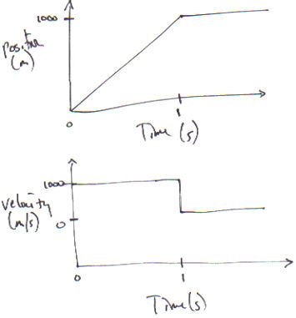

4) A circus elephant picks up a clown (who is not moving) and throws him across the ring at high speed.
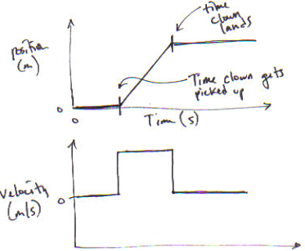

5) At track practice, the coach makes the team members run back and forth between two lines three times.
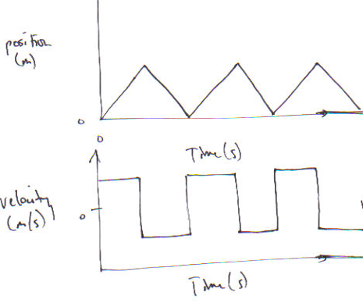

6) When you hit a golf ball, it travels through the air at 25 m/s, then decelerates once it hits the ground 100 meters away until it comes to a stop 110 meters away.
