VSEPR Worksheet

1) What is the main idea behind VSEPR theory?

2) For each of the following compounds, determine the bond angles, molecular shapes, and hybridizations for all atoms:

a) carbon tetrachloride

b) BH₃

c) silicon disulfide

d) C₂H₂

e) PF₃
VSEPR Worksheet - Solutions

1) What is the main idea behind VSEPR theory?

The main idea is that electrons don’t like to hang around near each other because they repel each other. As a result, the atoms in a molecule tend to separate as far as they can because their bonds repel each other.

2) For each of the following compounds, determine the bond angles, molecular shapes, and hybridizations for all atoms:

a) carbon tetrachloride
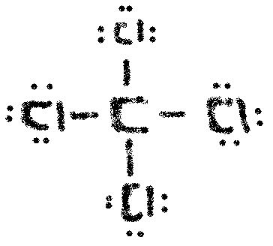
Carbon is tetrahedral, 109.5⁰ bond angle, and sp³ hybridized.

Chlorine is linear, has no bond angle, and is sp³ hybridized

b) BH₃
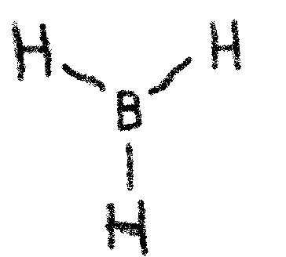
Boron is trigonal planar, 120⁰ bond angle, and sp² hybridized.

Hydrogen is linear, has no bond angle, and no hybridization

c) silicon disulfide
Silicon is linear, has a 180⁰ bond angle, and is sp hybridized.

Sulfur is linear, has no bond angle, and is sp² hybridized.
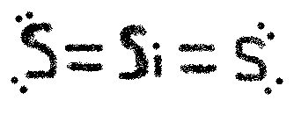

 d) C₂H₂
Carbon is linear, has a 180⁰ bond angle, and is sp hybridized.

Hydrogen is linear, has no bond angle, and no hybridization.

e) PF₃
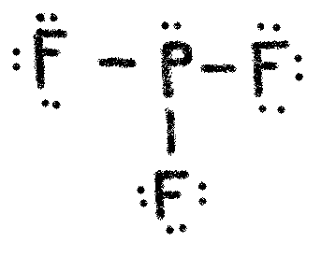
Phosphorus is trigonal pyramidal, has a bond angle of 107.5⁰, and is sp³ hybridized.

Fluorine is linear, has no bond angle, and is sp³ hybridized.

