Organic Functional Groups

Identify the functional groups in each of the following organic compounds:

1)
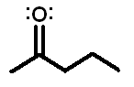

2)
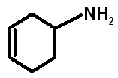

3)
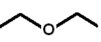

4)

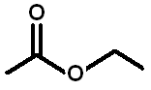

5)
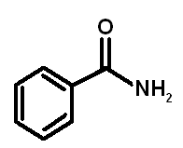
Organic Functional Groups

Identify the functional groups in each of the following organic compounds:

1) ketone

2) cycloalkene, amine

3) ether

4) ester

5) aromatic, amide

